**PHINMA UPANG COLLEGE URDANETA**

Nancayasan, Urdaneta City

Accountacy Business and Management

**11 ABM 2**

**BUSINESS PLAN**

Presented as Partial Fulfillment of the Requirement for

**ORGANIZATION AND MANAGEMENT**

Submitted to:

**ARNEL Z. BAUZON, MBA.**

Professor

Submitted by:

**11 ABM 2 – Group 4**

First Semester

Academic Year 2021 – 2022

**Chapter 1**

**Project Summary**

Disinfecting wipes is a hygiene product that protect consumers health and also essential to our lives today. Disinfecting wipes is known as cleaning agent on hard surface. It can be used in school, home and medical fields, as well as for personal hygiene purposes such as baby care, facial cleaning, and intimate personal cleansing. A vast selection of cleansing wipe products for a variety of uses has grown exponentially in recent decades.

The first soaked paper cleaning product was invented in the 1950s, and it was meant for cleaning on the go, as well as convenience of use and disposal. Manufactures realized that portable, disposable cleansing wipes could meet a variety of consumer requirements. Wipes can be packed separately, but they’re usually sold in bulk with easy-to-open packaging and resealable tabs to minimize moisture loss.

Back in the normal days when pandemic never happened disinfecting wipes are needed but when pandemic strike, it became a part to our daily life, since we need to be extra clean. We use it to disinfect our parcels, self and surfaces. With our own made disinfecting wipes, we make sure that its extra clean and affordable. We want our product to be essential not just during pandemic but in everyday life. Our Product also comes in a case which you can also organize your unused extra face mask. It can fit in your bag or pocket without occupying space too much

**Name of Enterprise**

The name of our enterprise is SanitiZall. We came up with this idea because, the wipes that we are producing can sanitize and disinfect everything. These wipes are convenient and safe to use in cleaning, especially nowadays, to prevent the spread of germs and infections. Moreover, we assure you that our product can clean, free a surface/object from bacteria, and disinfect it well, a product that can SANITIZE ALL (SANITIZALL)

**Business Logo**

There are extra factor in life if you give extra care to ourselves. The difference between a person with clean figure is more attractive, huggable, and safe to go with than a person who don’t do personal hygiene properly. This logo explains to us that life is better than golds. No matter how rich we are if we don’t have extra care to ourselves, either we harm or to harm other.

Square is the product (wipes), blue color means sensitivity and freedom, and green means it is the color of life. Cross inside the square is our health.

**Logo of our Enterprise**

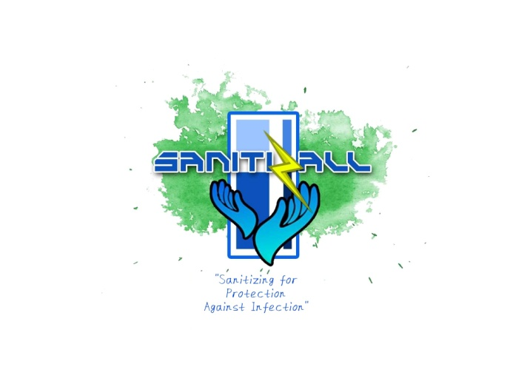

**Business Tagline**

Our tagline “Sanitize for Protection Against Infection” means that our disinfecting wipes are truly made for your protection. You can use it to protect yourself from diseases and infection. With our tagline we want the best to protect our citizen, that will never let you down when it comes to your protection against any viruses especially now that there is still Covid-19.

**Product Description**

Our SanitiZall Disinfecting Wipes has a non drying formula to moisture and keep skin soft and fragrantly smooth. It also comes with a refreshing scent and cooling after-feel. Apart from the obvious benefit of killing germs, bacteria, and viruses, SanitiZall Disinfecting Wipes can be used to clean just about anything around the house.

We are confident that our community will enjoy this product because they require it on a daily basis. People who frequently travel to other locations may require this. It will protect them from becoming sick or exposed to viruses outside.

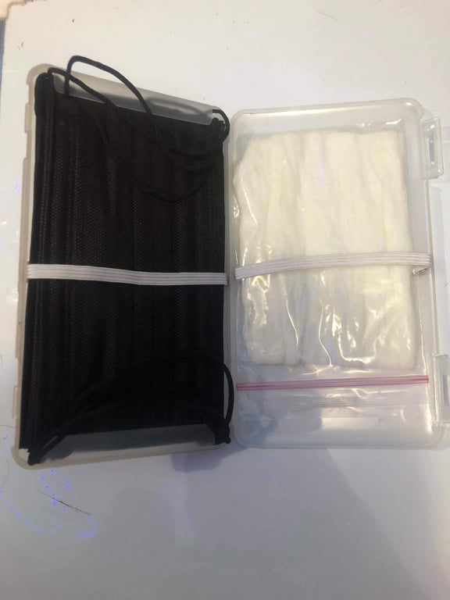**SanitiZall**

**Chapter II**

**Planning**

As a company that wants everyone to be protected, we serve our first product which is the sanitizing wipes in a compactable case. But, we will not stop to serve necessities to our beloved customers. We will launch new products every 5 months. We want to make it precise and best at possible. The organization is determine to serve our product locally and even globally by supplying, advertising and making it accessible in various online websites. Not seeing our beloved customers face will never be okay. Our physical store is in now in a planning stage. Be sure to check it once it is available, we care about your comfortability. Expansion and branches of our store will be decided in the upcoming years. Serving and helping our locals is also in our future plans.

In the next 10 months SanitiZall will offer customers a new option for disinfecting surfaces. Given that our product is disinfecting wipes, we would like to add disinfectant sprays. Disinfectant sprays can be sprayed on keyboards, phones, books, and other areas of the house without damage or concern. After 5 years, we will have some activities and program that is conducted for who's in needs. To stay competitive in today’s on-demand world, we might consider electronic commerce, and offer online services via which users can order things and have them delivered to them. Customers will be able to purchase the products on our premises as well. The process is often very quick as the customers can place orders in a relatively short period of time, without having to leave their homes or offices and transport the goods to the costumer’s desired locations. E-commerce doesn’t provide benefits to customer and consumers only; it is an advantage for our company as well. With e-commerce, we can increase online sales through social media.

Malls, restaurants, retail shops, grocery, supermarkets, and wholesalers will be our primary customers. These consumers have a good profit margin and are able to purchase quickly. Individual clients, such as households who utilize our products, will also be sold to. Our market share will be distributed throughout Pangasinan and the surrounding territories. The majority of our consumers will be repeat customers who will purchase from us on a regular basis. On a daily and weekly basis, primarily. Some may pay in cash, while others will use an electronic payment system. Individual consumers, supermarkets, hospitals, and restaurants will be among our clients. The majority of them will be repeat clients who will purchase our items on a regular basis. This will ensure that our items are purchased in the future. We will perform strong advertising in the beginning to raise awareness of our items among potential clients. To ensure that we achieve the specified market share, we will also provide our consumers inexpensive prices that are lower than those of our competitors.

Soon in the future our company will be popular in the Asian business because of our product and by the reason of how we get along with our employee or how we respect and obey our rules. And in the future our main company will have a small branches in different places.

**Chapter III**

**Organizing and Staffing**

Organizing entails establishing a pattern of interactions among workers and making the best use of the resources available to ensure that plans are carried out successfully. Staffing can be defined as one of the most important functions of management. It

includes job analysis of people with the necessary skills for appropriate jobs.

The more people are available to work, the faster projects can be completed or the more projects a company can take on. Conversely, a lack of adequate manpower prevents businesses from completing tasks. Assigning tasks, arranging tasks into departments, distributing power, and allocating resources across the organization are all part of the organizing process. Managers organize personnel, resources, rules, and procedures during the organizing process to help achieve the plan's objectives.

**Organizational Structure**

The organizational structure of SanitiZall is well-developed. The organization is essential for the smooth running of our company. Each member of the team contributes their fair share of the workload and fully understands what their responsibilities are and where they fit in with the running of the business. Though each individual should be responsible for organizing their workload, our management ensures that everything is running into the organizations plan and each of us is getting their work completed efficiently. In all aspects, employing people for their proper jobs and experiences each department have coordination to each other to achieve SanitiZall success in disinfecting wipes market globally.

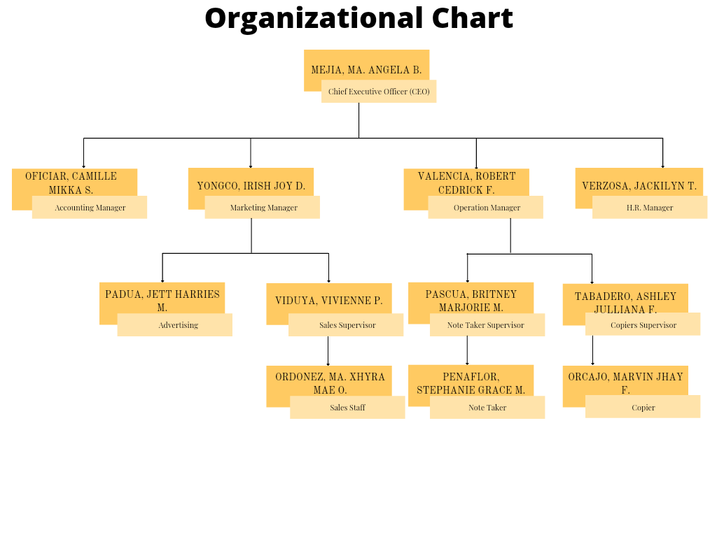**Organizational Chart**

**Compensation and Benefits**

SanitiZall offers compensation and benefits to our employees. Benefits are highly effective way of keeping their loyalty at work. Incentives are linked to an employees performance, so they work in the same way as a prize. To encourage them to do their work more effectively and to be more competitive employee.

This are the compensation and benefits categories of SanitiZall to our employees:

1. Health benefits
2. Life Insurance
3. Food Allowance
4. Transportation Allowance
5. Monthly Bonus

**Health Benefits**

Health benefits can boost overall productivity, reduce absenteeism, enhance employee nutrition habits, and encourage favorable behavioral patterns. In this way SanitiZall employees don’t have to worry about the expenses if they got health problems.

**Life Insurance**

Life insurance is essential, because it protects your family and allows you to leave them an amount that is not taxable when you die. It can also be used to pay off your mortgage and personal loans, such as a vehicle loan. Our company provides life insurance to secure the future of our employee on whatever accident may happen.

**Food Allowance**

Food allowance allows employee to eat what they want while staying within their budget and without having to worry about the time or cost of cleaning up. Our company provides food allowance to those employee who are deployed in far branches of SanitiZall.

**Transportation Allowance**

This is provided by our company which is used by an employee to purchase transportation services for commuting to the worksite. Specially marketing and networking department in this way employee will not think about their fair on seeking potential investors and costumers.

**Monthly Bonus**

Monthly bonus is given to our employees for sales department to reward performance and increase employee retention. Our employee would get cash bonus if they hit their monthly sales quota.

**Resume**

**MA. ANGELA B. MEJIA**

***#393 Caballes St. Tayug, Pangasinan Philippines.***

***Cell #:+639914579940***

***Email: maba.mejia.up@phinmaed.com***

**Objective:** To work as a CEO in an organization where experience in performing general administrative and executive duties will be fully utilized to ensure smooth running of all company operations.

**PERSONAL INFORMATION:**

* Date of Birth : July 16, 2004
* Place of Birth : Tayug, Pangasinan Philippines
* Civil Status : Single
* Citizenship : Filipino
* Language/Dialect : English and Tagalog
* Religion : Roman Catholic
* Father : Rocky A.Mejia(Deceased)
* Mother : Rosemarie B. Mejia

**EDUCATIONAL BACKGROUND:**

Elementary : Tayug Central Elementary School

Tayug, Pangasinan Philippines

2011-2017

High School : Tayug National High School

Tayug, Pangasinan Philippines

2017-2021

**SKILLS/SEMINARS/TRAINING’S:**

SKILLS:

* Project Management
* Marketing Strategist
* Strong Written and Verbal Skills
* Strategic Thinker
* Great Leadership Qualities
* Effective Communication Skills

AWARDS:

* Chief Executive of the Year (2018)
* With Honors (2017–2021)

TRAINING:

* Ateneo Center for Continuing Education (2016-2018)
* Executive Assistant to the CEO Detroit, MI (2019)

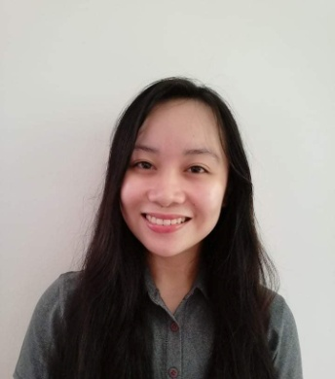**CAMILLE MIKKA S. OFICIAR**

***Oraan West, Manaoag, Pangasinan***

***Cell #:+6396721005170***

***Email: oficiarcamille@gmail.com***

**Objective:** To pursue my career with an organization that will utilize my management, supervision, and administrative skills.

**PERSONAL INFORMATION:**

* Date of Birth : October 16, 2003
* Place of Birth : Baguio City Philippines
* Civil Status : Single
* Citizenship : Filipino
* Language/Dialect : English and Tagalog
* Religion : Roman Catholic
* Father : Edwin E. Oficiar
* Mother : Jocelyn S. Oficiar

**EDUCATIONAL BACKGROUND:**

Elementary : St. Camillus College of Manaoag

Manaoag, Pangasinan Philippines

2007-2017

High School : St. Camillus College of Manaoag

Manaoag, Pangasinan Philippines

2017-2021

**SKILLS/SEMINARS/TRAINING’S:**

SKILLS:

* Leadership Skills
* Communication Skills
* Management Skills
* Collaboration Skills

AWARDS:

* With High Honors (2007-2021)

TRAINING:

* Division Seminar-Workshop on Campus Journalism for Pupil Writers (2015)

**IRISH JOY D. YONGCO**

***Laoac East, Alcala, Pangasinan***

***Cell #:+639465115824***

***Email: irishjoydyongco@gmail.com***

**Objective:** To ensure a friendly surrounding and to work with creativity, passion and determination within the organization

**PERSONAL INFORMATION:**

* Date of Birth : January 16, 2005
* Place of Birth : San Carlos Philippines
* Civil Status : Single
* Citizenship : Filipino
* Language/Dialect : Tagalog
* Religion : Roman Catholic
* Father : Edilberto S. Yongco Jr.
* Mother : Irene D. Yongco

**EDUCATIONAL BACKGROUND:**

Elementary : Laoac Elementary School

Alcala, Pangasinan Philippines

2011-2017

High School : Cipriano P. Primicias National High School

Alcala, Pangasinan Philippines

2017-2021

**SKILLS/SEMINARS/TRAINING’S:**

SKILLS:

* Management Skills
* Leadership Skills
* Marketing Skills

AWARDS:

* Consistent Honor (2011-2021)
* Leadership Award

TRAINING:

* Leadership Division Training (2016)

**ROBERT CEDRICK F. VALENCIA**

***Palina West, Urdaneta City Pangasinan***

***Cell #:+639759890781***

***Email: roced.valencia@gmail.com***

**Objective:** To work as professional operations manager applying my organizational skills and knowledge of standard operational procedures to achieve company goals.

**PERSONAL INFORMATION:**

* Date of Birth : November 05, 2005
* Place of Birth : Tayug, Pangasinan Philippines
* Civil Status : Single
* Citizenship : Filipino
* Language/Dialect : English, Tagalog and Ilocano
* Religion : Roman Catholic
* Father : Roberto D. Valencia Jr.
* Mother : Cindylyn S. Fontanilla

**EDUCATIONAL BACKGROUND:**

Elementary : San Rafael Elementary School

San Nicolas, Pangasinan Philippines

2011-2017

High School : San Rafael National High School

San Nicolas, Pangasinan Philippines

2017-2021

**SKILLS/SEMINARS/TRAINING’S:**

SKILLS:

* Planning Skills
* Knowledge Skills
* Time Management Skills
* Active Listening
* Problem Solving Skills

AWARDS:

* Innovation Award
* Diligence Award
* Most Creative Award
* Behavior and Value Award
* Outstanding Service Record

TRAINING:

* Operations Management and the Organization (2017)
* Product and Service Management (2017-2018)
* Facilities Planning and Management (2019-2021)

**JACKILYN T. VERZOSA**

***Anis, Laoac PangasinanCell#:+639300964834***

***Email: jata.verzosa.up@phinmaed.com***

**Objective:**To maintain and enhance human resources productively in an organization, developing strong manpower, identifying talent and deploying professional development programs in order to achieve organizational goals and fulfill employees’ needs.

**PERSONAL INFORMATION:**

* Date of Birth : September 09, 2005
* Place of Birth : Anis, Laoac Pangasinan
* Civil Status : Single
* Citizenship : Filipino
* Language/Dialect : English, Tagalog, and Ilocano
* Religion : Roman Catholic
* Father : Celestino C. Verzosa
* Mother : Imelda T. Verzosa

**EDUCATIONAL BACKGROUND:**

Elementary : Urdaneta 1 Central School

Urdaneta City, Pangasinan Philippines

2011-2017

High School : Lyceum Northern Luzon

Urdaneta City, Pangasinan Philippines

2017-2021

**SKILLS/SEMINARS/TRAINING’S:**

SKILLS:

* Management Skills
* Leadership Skills
* Problem-solving Skills
* Communication Skills
* Advising Skills

AWARDS:

* Valedictorian (2011-2017)
* With Honor (2017-2019)

**JETT HARRIES M. PADUA**

***Bila Highway, Sison PangasinanCell#:+639473355761***

***Email: awiesmawiano@gmail.com***

**Objective:**To maintain and enhance human resources productively in an organization, developing strong manpower, identifying talent and deploying professional development programs in order to achieve organizational goals and fulfill employees’ needs.

**PERSONAL INFORMATION:**

* Date of Birth : October 20, 2003
* Place of Birth : Las Piñas
* Civil Status : Single
* Citizenship : Filipino
* Language/Dialect : Tagalog
* Religion : Roman Catholic
* Father : Vieli Maris R. Padua
* Mother : Ma. Theresa T. Mariano

**EDUCATIONAL BACKGROUND:**

Elementary : Asan Sur Elementary School

Sison, Pangasinan Philippines

2011-2016

High School : Benigno V. Aldana National High School

Pozorrubio, Pangasinan Philippines

2017-2021

**SKILLS/SEMINARS/TRAINING’S:**

SKILLS:

* Communication Skills
* Creativity
* Active Listening
* Computer Skill
* Commercial Awareness
* Research Skill

AWARDS:

* Excellence in Brand Strategy Gold UOB Cards
* Excellence in Advertising Gold Manulife Singapore

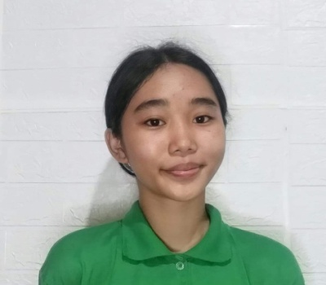**VIVIENNE P. VIDUYA**

***#304 Panila East Urdaneta City Pangasinan***

***Cell#:+639064951646***

***Email: vipi.viduya.up@phinmaed.com***

**Objective:**To obtain a career in costumer service relations and utilize my professional experience and skills to become a great asset to growing a company.

**PERSONAL INFORMATION:**

* Date of Birth : February 03, 2005
* Place of Birth : Urdaneta City Pangasinan
* Civil Status : Single
* Citizenship : Filipino
* Language/Dialect : Tagalog, and Ilocano
* Religion : Roman Catholic
* Father : Celestino C. Verzosa
* Mother : Imelda T. Verzosa

**EDUCATIONAL BACKGROUND:**

Elementary : Palina East Elementary School

Urdaneta City, Pangasinan Philippines

2011-2016

High School : Palina East National High School

Urdaneta City, Pangasinan Philippines

2017-2021

**SKILLS/SEMINARS/TRAINING’S:**

SKILLS:

* Management Skills
* Leadership Skills

AWARDS:

* With Honors (2011-2021)
* Girls Scout of the Year

TRAININGS:

* DSPC Urdaneta City (2015-2016)
* Division Leadership Training (2018-2019)

**BRITNEY MARJORIE M. PASCUA**

***Mabini St. Rosales Pangasinan***

***Cell#:+639281740868***

***Email: Britneypascua@yahoo.com***

**Objective:**To obtain a Note Taker position in an organization where I can gain additional experience, expand on my creativity and organizational skills.

**PERSONAL INFORMATION:**

* Date of Birth : February 23, 2005
* Place of Birth : Rosales Pangasinan
* Civil Status : Single
* Citizenship : Filipino
* Language/Dialect : Tagalog
* Religion : Roman Catholic
* Father : Raymundo T. Pascua
* Mother : Marilou M. Pascua

**EDUCATIONAL BACKGROUND:**

Elementary : Rosales Adventist Multigrade School

Rosales, Pangasinan Philippines

2011-2016

High School : Rosales High School

Rosales, Pangasinan Philippines

2017-2021

**SKILLS/SEMINARS/TRAINING’S:**

SKILLS:

* Time Management
* Transferable Skills
* Active Listening
* Judgment and Decision making

AWARDS:

* With Honors (2021)

TRAININGS:

* Lecture Note TakerHerCampus UCSD (2014)

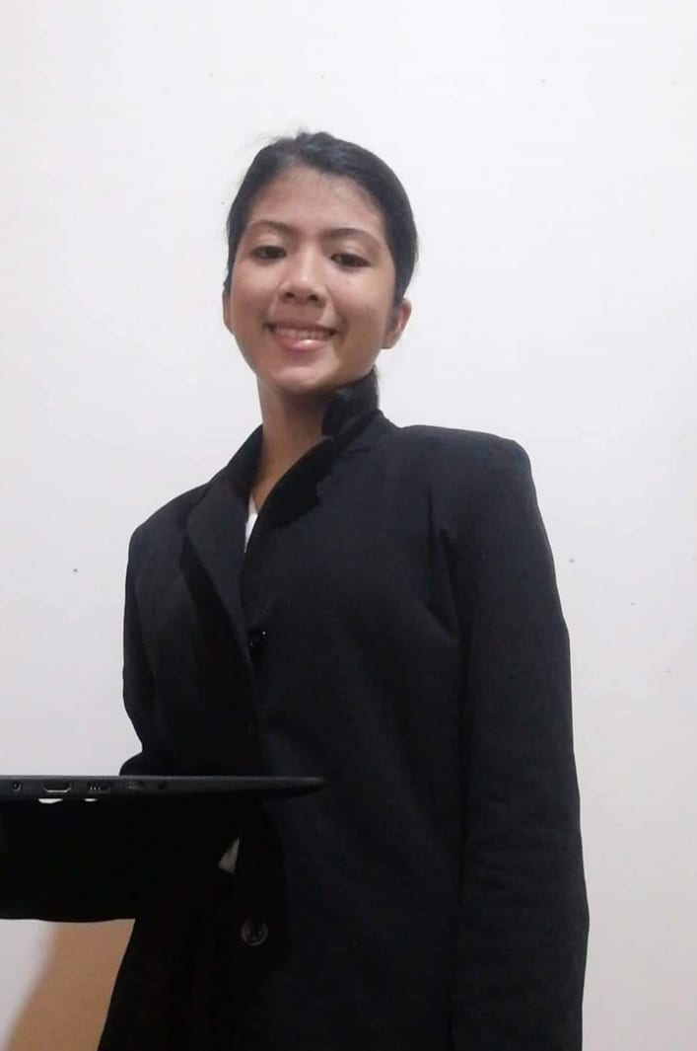**ASHLEY JULLIANA F. TABADERO**

***Brgy. Libis, San Carlos City Pangasinan***

***Cell #:+639124698807***

***Email: ashleyjullianatabadero@gmail.com***

**Objective:** To ensure the development of consistently superior marketing materials that support established marketing strategies and project.

**PERSONAL INFORMATION:**

* Date of Birth : July 17, 2005
* Place of Birth : Libas, San Carlos City Pangasinan
* Civil Status : Single
* Citizenship : Filipino
* Language/Dialect : Tagalog and Ilocano
* Religion : Roman Catholic
* Father : Jay Caesar E. Tabadero
* Mother : Maria F. Tabadero

**EDUCATIONAL BACKGROUND:**

Elementary : Libas Elementary School

San Carlos City, Pangasinan Philippines

2011-2017

High School : Libas National High School

San Carlos City, Pangasinan Philippines

2017-2021

**SKILLS/SEMINARS/TRAINING’S:**

SKILLS:

* Communication Skills
* Problem Solving Skills
* Managing Time Skills

AWARDS:

* Academic Award
* Most Behave

TRAININGS:

* ABC Corporation (2018-2020)

**MA. XHYRA MAE O. ORDONEZ**

***Tambod, Villasis Pangasinan***

***Cell #:+639063842095***

***Email: xhyraordonez@gmail.com***

**Objective:** To apply my advanced knowledge of sales and customer service and my experience with team-building and staff development.

**PERSONAL INFORMATION:**

* Date of Birth : July 21, 2005
* Place of Birth : Tombod, Villasis Pangasinan
* Civil Status : Single
* Citizenship : Filipino
* Language/Dialect : Tagalog
* Religion : Roman Catholic
* Father : Aumar M. Ordonez
* Mother : Ma. Mae O. Ordonez

**EDUCATIONAL BACKGROUND:**

Elementary : Tombod Integrated School

Villasis, Pangasinan Philippines

2011-2017

High School : Tombod Integrated Scholl

Villasis, Pangasinan Philippines

2017-2021

**SKILLS/SEMINARS/TRAINING’S:**

SKILLS:

* Communication Skills
* Repport-building Skills
* Managing Time Skills
* Active Listening Skills
* Time Management Skills
* Product Knowledge

TRAININGS:

* SALES ASSOCIATE H&M (2017)

**STEPHANIE GRACE M. PENAFLOR**

***Alipangpang, Pozorrubio Pangasinan***

***Cell #:+639687761237***

***Email: penaflorstephaniegrace63@gmail.com***

**Objective:** To capture the company’s information completely and accurately.

**PERSONAL INFORMATION:**

* Date of Birth : July 22, 2004
* Place of Birth : Tantay, Rizal Philippines
* Civil Status : Single
* Citizenship : Filipino
* Language/Dialect : Tagalog and English
* Religion : Roman Catholic
* Father : Jonah N. Penaflor
* Mother : Annalee M. Penaflor

**EDUCATIONAL BACKGROUND:**

Elementary : Doñna Nieves Songco Memorial Elementary School

Angono, Philippines

2011-2017

High School : Benigno V. Aldana National High School

Pozorrubio, Pangasinan Philippines

2017-2021

**SKILLS/SEMINARS/TRAINING’S:**

SKILLS:

* Customer and Personal Service
* Social Perceptiveness
* Time Management

**MARVIN JHAY F. ORCAJO**

***Zone 6, Pasileng Sur, Binalonan Pangasinan***

***Cell#:+63909423531***

***Email: Marvinjhay2005@Gmail.com***

**Objective:**To produce paper copies of a document. Most photocopiers use laser technology, a dry process that uses electrostatic charges on light-sensitive photoreceptor to transfer toner onto paper to form an image.

**PERSONAL INFORMATION:**

* Date of Birth : February 13, 2005
* Place of Birth : Pasileng Sur, Binalonan Pangasinan
* Civil Status : Single
* Citizenship : Filipino
* Language/Dialect : Tagalog, and Ilocano
* Religion : Roman Catholic
* Father : Roger S. Orcajo
* Mother : Reichell F. Orcajo

**EDUCATIONAL BACKGROUND:**

Elementary : East Central Integrated School

Dagupan City, Pangasinan Philippines

2011-2017

High School : East Central Integrated School

Dagupan City, Pangasinan Philippines

2017-2021

**SKILLS/SEMINARS/TRAINING’S:**

SKILLS:

* Understand Written Infromation
* Understand Spoken Information
* Listen to others and ask questions

**Chapter IV**

**Democratic Leadership Style**

The Democratic Leadership is the style that we choose, because it is the idea of all the employees and also costumers. In that way we can address every single problem or any suggestion that can enrich the company’s future. And because of everyone’s opinion and suggestion, we can analyse a better strategy for the improvement of our company. . Furthermore, Democratic Leadership is also helping our employees to reach their goals in life, not only our company but also ensuring the growth of our team financially and morally. Because the growth of everyone is a sign that our company is aiming our goals and have a team work for growth. Working under a democratic leader is the best approach to become a democratic leader. You can prepare to be a thought-provoking, insight-seeking boss or manager by making major decisions, working with the team, and taking leadership training, where everyone can contribute their own thoughts and we can communicate with each other to identify what are the do's and don'ts. Each will have the opportunity to speak, but they must be aware of their limitations, because a true leader will listen to and learn from his or her employees. We will be able to convey our thoughts or plans for our business in this format. We believe that this is the most effective type for our organization because if there will be a time that we will experience business issues, we, employees, can give our opinions, and our leader will get a variety of solutions to choose from.

**Social Obligation and Responsibility**

SanitiZall has a lot of mission and vision to fulfil, and one of it is to help children. One of our mission is to help children who’s in need, children who are in foster care and children who needs more love and attention. In cooperation with foundations and other organizations who care for foster children, we would like to teach them the proper hygiene care to avoid sickness and give some of our products to help them protect themselves. Youth is the hope of the nation, and we want to give a helping hand to our youth.

We SanitiZall believe that knowledge on fighting bacteria and viruses can also save lives. As young as possible we must practice and maintain proper hygiene so we made this kind of program.

**Chapter V**

**Controlling**

Control management is essential to our business because it helps us to check errors and implement corrective action, minimizing deviation from standards, and keeps our project management on track. With such a framework in place, our company is much more likely to hit its goals. Controlling helps managers monitor the effectiveness of their planning, organizing, and leading activities. This is also comparing an actual performance to help managers understand where they are lacking and how they can improve their performances. In this way, we can identify if the plan is effective or revise it for better improvement. The pros and cons can differentiate immediately to lessen loss, and with proper controlling we can come up with corrective actions.

**SWOT Analysis**

SWOT Analysis is a simple yet effective framework for examining your company's strengths, weaknesses, opportunities, and threats. It enables you to expand on what you've already accomplished properly, to address what you're lacking, to reduce risks, and to maximize your chances of success. The basic goal of a SWOT analysis is to aid in decision-making. Organizations gain a complete understanding of all the aspects that go into running a firm. SWOT analysis is a strategic planning technique that can assist you in determining what your firm does best right now and developing a successful future strategy.

Table: SWOT Analysis

|  |  |
| --- | --- |
| **Strengths:**   * **Delicate and Eco Friendly** * with the high contains of cotton it cannot harm every types of skin and its easly decomposed. * **Handy and Affordable** * unlike any other tissue its came with very small packaging but more content and its price is cheaper compare to other brand. * **Accessible** * its available even in sari-sari store or any bus station. | **Weakness:**   * **Lots of Competitor** * many companies also selling our kind of product. * **Not Popular Brand** * people don’t know that SanitiZall is the best product of tissues and sanitizers. |
| **Opportunities**   * **Developing New Products** * we are not just focusing on sanitizers but also making for new product that can fight viruses. | **Threats**   * **Many Available Product** * because of competition there’s a lot of choices in the market. * **Lock of Ingredients** * because of limit sources of trees that can produce cotton. |

**Production Process**

In our production process, we ensure that everyone understands their role and place, an emphasis on the importance of safety, employee health and a fairly clean work environment for our employees in a subtle way. Every employee is generally well equipped and machines are properly checked and all the ingredients are available. We also essentially ensure that our workers would always wear their proper uniform to perform or actually start the production so that they can prevent any hazardous things that might happen.

**The Production Process**

|  |
| --- |
| 1. Wear your gloves. |
| 1. Place the paper towel in a large container. |
| 1. Pour the alcohol and water mixture into the container. |
| 1. Soak the wipes for at least 5 minutes. |
| 1. Pack it in a ziplock pouch, and put it in the case and it’s ready to use. |
| 1. Glue the garter to the box’s edges. |
| 1. Wait for it to dry. |
| 1. Apply the freebie facemask to the other side of the box. |
| 1. Place the zip locked disinfecting wipes on the other side. |
| 1. Glue the logo to the box’s front. |
| 1. Finish locking the box and it’s ready to go. |

**SanitiZall Enterprise Policies and Regulations**

The policy of our company is implemented to all employees of Sanitizall. Every employee must follow and obey the firm authority's act, direction, policy, rules, and regulations as they apply from time to time.

Employees should always wear their proper uniforms to easily identify their departments. Maintain cleanliness and proper hygiene, to avoid spreading the disease in the company and it’s the main agenda of SanitiZall cleanliness. Come on time, being late is not tolerable in SanitiZall. Leaves and Absences, all leaves whether paid or unpaid, must be approved ahead of time. If the employee are unable to report to work for whatever reason, contact the manager as soon as possible, either by phone or personal messenger, to advise your absence and, if possible, when you will be able to return to work. Employees should eat during their lunch breaks. Because the company will not provide extra time for meals, employees are encouraged to make the most of their break time. Our organization is committed to upholding the ethical principles of its employees. Employees who engage in malpractices will be fired without warning by the company. Be kind to each and every one and be cooperative and have team work, in this way we can achieve the company’s success.